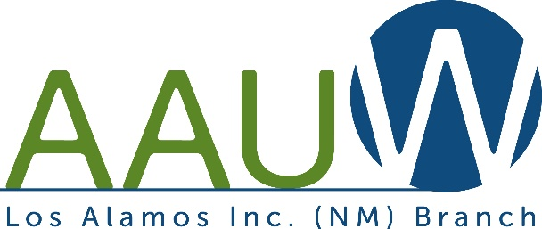

American Association of University Women
2022-2023 Scholarship Application Form

The Los Alamos Branch of the American Association of University Women is offering this scholarship to encourage a non-traditional female student to pursue her goal of completing her Certificate, Associate’s or Bachelor’s Degree at UNM-Los Alamos.

Requirements:

- Must demonstrate financial need. (Complete current year FAFSA)

- Must be enrolled in a certificate or degree seeking program
- Must be enrolled in at least 8 credit hours per semester (fall/spring)
- Must maintain a 2.5 GPA to continue eligibility
- Must submit a new application each year
- Must submit a short essay (not more than one page) explaining why you want to attend school, what your goals are and how this scholarship will help.
- Student must be a female non-traditional student returning to school or just starting education after several years out of high school.

The selection process will be conducted by a committee of members of the Los Alamos Branch of the American Association of University Women. The award amount will be $1000 for the school year (fall/spring).

Scholarship application deadline is Wednesday, August 31, 2022.

All the information submitted is true and complete to the best of my knowledge. I do hereby consent to the release of information concerning my academic and financial status to scholarship donor, for consideration of scholarship eligibility and publication purposes.

Signature Date Student’s UNM ID
Please return the completed application packet to Jenny Duran in the UNM-LA Student Support Services Office in Building 1.

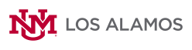
Jenduran@unm.edu
UNM-LA
4000 University Dr. Los Alamos, NM 87544

